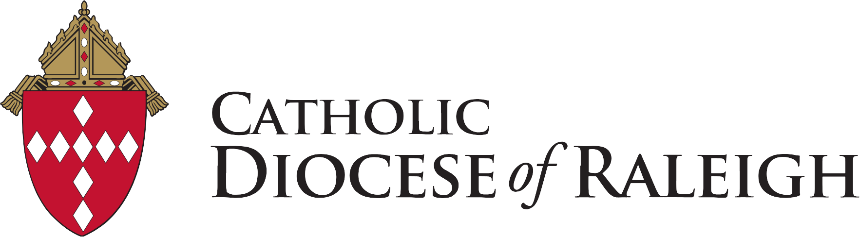
Diocese of Raleigh Student Art Showcase
Co-sponsored by Offices of Education & Human Life & Dignity
‘How Do I Care for God’s Creation?’
How Do I Care for God’s Creation? connects to the Catholic Social Justice theme of Rights and Responsibilities for the 2025-2026 School year. “The Lord God then took the man and settled him into the garden to of Eden to cultivate and care for it” GN 2:15 “The Lord’s are the earth and its fullness; the world and those who dwell in it.” PS 24:1
Artwork idea/s:
Design an original artwork in horizontal orientation in any medium that shows how the student cares for God’s creation. ECC - Pre-K classes may submit a class project.
Eligibility: All students in the Diocese of Raleigh Catholic schools are eligible.
Participating Gift:
Students selected for the showcase will receive a certificate from Bishop Zarama. All participating students will receive a small gift from NC Catholics Caring for our Common Home.
Showcase Rules:
Each entry must be the original work of the student.
Deadline: Submissions are due by Friday, March 20, 2026. This will allow time for compiling the NC Catholic sMagazine online showcase of selected artwork and distribution of participant gifts.
Submission of Selected Artwork: Teachers, please submit a total of 3 pieces of art from each of these grade categories:

ECC - 2nd grades | 9th -10th grades
3rd - 5th grades | 11th - 12th grades
6 - 8th grades

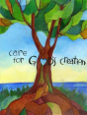
Send images of artwork in horizontal orientation, .jpg format and 16:9 size with student name, and the completed Teacher Submission Form to the Art Showcase committee at: michellerose@nccommonhome.org.The submitted artworks will be featured online by NC Catholics Magazine to celebrate Earth Day, April 22, 2026. The link to the Showcase will be provided. Schools are encouraged to display the artwork in their parish.

School ENEWS Blurb: Our students are participating in the Diocesan Art Showcase “How Do I Care for God’s Creation”? Please talk with your student(s) about what they or your family are or can do to Care for God’s Creation. NC Catholics will unveil the Art Showcase on Earth Day, April 22, 2026.

For questions, contact the Art Showcase committee at: michellerose@nccommonhome.org

Talking Points for Teachers
Questions Teachers can bring forward:
• Is creation a work of God?
• What does our faith tell us about how we need to care for the Earth and all who dwell on Earth?
• What Bible story tells of God giving someone a first job? Genesis 2:15
• Does God's Home exclude anyone or any creature?
• How can we live more lightly upon the land?
Videos and other resources related to the 2015 Papal encyclical Laudato Si’: On Care of our common Home and Catholic Social teaching on creation care
Preschool
2 Creation stories Genesis 1:1 - 2:20
The Lorax by Dr. Suess
Elementary
• Laudato Si – CRS Elementary Animated Brief-A short, animated video that provides a quick summary of Laudato Si' for elementary aged students. The video was created in collaboration with Caritas Catholic international humanitarian aid organizations throughout the world.
Grade K-2 Read Green Street Park, a copy of the book will be donated to your school library by NC Catholics Caring for Our Common Home. Consider the Talk About Questions for Religion, Social Studies and ELA. Additional lesson plans https://store.loyolapress.com/site/assets/discussion-gd/two-feet-green-street-BLMs.pdf
Optional video version https://www.usccb.org/beliefs-and-teachings/what-we-believe/catholic-social-teaching/two-feet-storybooks
Grades 2-4 Read Drop by Drop, a copy of the book will be donated to your school Library by NC Catholics Caring for Our Common Home. Consider the Talk About Questions for Religion, Social Studies and ELA. Additoinal lesson plans https://store.loyolapress.com/site/assets/discussion-gd/two-feet-drop-by-drop-BLMs.pdf

Middle School
• https://www.sbdiocese.org/LaudatoSi/Documents/care-for-gods-creation-quiz.pdf- A quiz with questions and answers about why and how we can care for God’s creation. From CRS
CST 101 | Rights and Responsibilities
https://www.crs.org/sites/default/files/2025-04/17us495_cst_handout-adult_en-digital.pdf
High School
• Laudato Si – CRS High School Animated Brief - The video was created in collaboration with Caritas Catholic international humanitarian aid organizations throughout the world.
• https://ignatiansolidarity.net/ignatian-carbon-lenten-challenge/ -Fasting from single-use plastics – from Ignatian Solidarity Network
• https://ourcommonhome.org/media/docs/friending-planet-earth.pdf – from Catholic Climate Covenant
• Catholic Social Teaching 101 Video Series | CRS – https://youtu.be/wSnXuCxiHXE - Care for God’s Creation – video.
• Catholic Curriculum | Laudatosiforall | United States (laudato-si-for-all.com) - Developed by the Carmelite NGO, this comprehensive Curriculum is available to ALL to download or in hard copies. For High School.

